Calculate the surface area to volume ratio of the following model cells:

|  |  |
| --- | --- |
| http://legacy.owensboro.kctcs.edu/gcaplan/anat/Notes/size-surfae%20area.jpg | http://legacy.owensboro.kctcs.edu/gcaplan/anat/Notes/size-surfae%20area.jpg |

SA

V

SA:V

Decide whether each of the following statements is better describes the 1mm or 2mm model cell. Justify your answer with your calculations.

* This cell has likely just entered G1 phase of the cell cycle.
* Diffusion of nutrients and oxygen throughout the cell is rapid.
* This cell is just about ready to undergo M phase.

Label all of the following structures on the diagram of DNA below:

* Nitrogenous bases: adenine, thymine, guanine, uracil
* Phosphate group
* Dexoyribose sugar
* Nucleotide
* 3’ & 5’ end

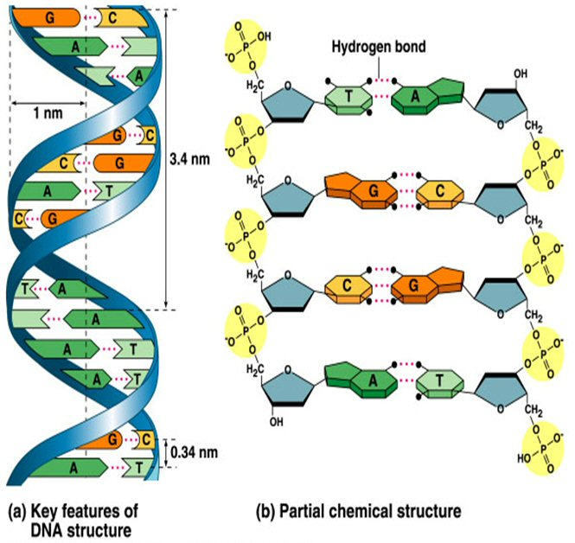

Why is this molecule said to be antiparallel?

Use the diagram below to discuss the major events of DNA replication. Be sure to include:

* The phase of the cell cycle during which this process takes place
* The purpose of this process with respect to the cell cycle
* The roles of helicase and DNA polymerase
* The differences between synthesis of the leading and lagging strand

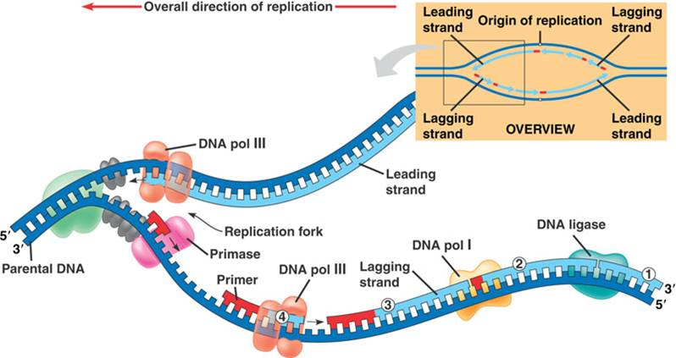

The process of DNA replication is said to be semiconservative. *Semi-* means “half” or “part” while *conserve* means “to save”. Why is this an appropriate way to describe this process?

The following is a parental template strand of DNA. What would the complimentary strand of DNA look like after replication is completed? (Hint: use your base-paring rules to write the complimentary strand beneath the parental strand.)

|  |  |  |  |  |  |  |  |  |  |  |  |  |  |  |  |
| --- | --- | --- | --- | --- | --- | --- | --- | --- | --- | --- | --- | --- | --- | --- | --- |
| **5’** | **G** | **A** | **T** | **G** | **A** | **C** | **C** | **T** | **A** | **A** | **G** | **T** | **C** | **A** | **3’** |

DNA and RNA are both nucleic acids that are involved in coordinating cellular functions. Complete the below chart in which you compare the types of nitrogenous bases, strandedness, sugar, and overall function.

|  |  |  |
| --- | --- | --- |
| DNA | Both | RNA |
|  |  |  |

For each scenario, identify which type of cell division (mitosis or meiosis) would be involved and explain why.

* Development of an embryo 🡪 fetus 🡪 infant
* Healing of a surgical incision
* Preparation of an egg to be released by the ovary

Describe the difference between sexual and asexual reproduction in terms of the biological process that is involved and the genetics of the offspring compared to the parents.

* Which type of reproduction would be involved in self-pollination of a flowering plant? Explain.
* Some organisms, such as jellyfish are able to choose when to carry out sexual or asexual reproduction. Under what kind of environmental conditions might each type of reproduction be most favorable?

Discuss the function of the checkpoints that occur during the cell cycle.

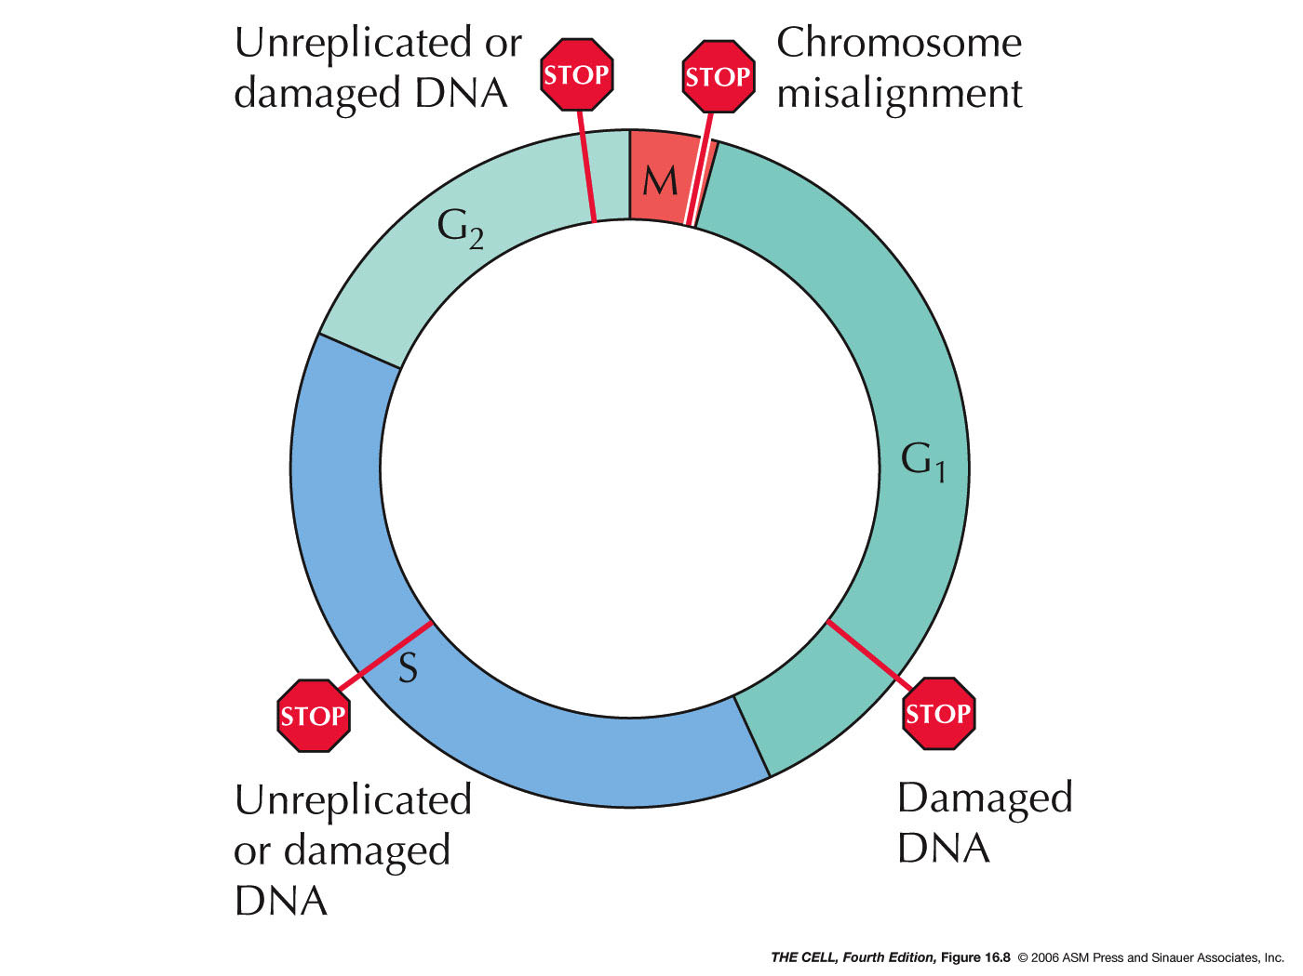

* What options does the cell have if the DNA is damaged? Which proteins are involved in helping to carry this out?
* What if the DNA is OK at each checkpoint? Which proteins are involved in helping to carry this out?
* What can happen at a checkpoint if there is a mutation in a proto-oncogene?
* What can happen at a checkpoint if there is a mutation in a tumor suppressor gene?

If you were to develop a drug that stopped angiogenesis, how might that impact the growth of a tumor in the body? Explain.

What is the difference between homologous chromosomes and sister chromatids? Use an illustration to help with your explanation.

In which phases of mitosis and meiosis would you expect to find sister chromatids still together?

In which phase of mitosis and meiosis would you expect to see homologous chromosomes separating? (Draw a picture of each!)

What process is being shown in the diagram below?

* When does this process occur?
* What is the result of this process?

